# Front cover

## Greater Waterbury Community Wellbeing Profile

## 

## Logos

## 

# About the Greater Waterbury Health Partnership and this Report (Page 2)

We Believe in a Collaborative Approach to Community Health.

The Greater Waterbury Health Partnership was formed in 2013 to better understand the health and wellbeing of greater Waterbury residents through data collection and community conversations. The partnership includes the following health leaders: City of Waterbury-Department of Public Health, Connecticut Community Foundation, Saint Mary’s Hospital, StayWell Health Center, Inc., United Way of Greater Waterbury, and Waterbury Hospital.

Our vision is to create a healthy Waterbury for all. This was adopted after convening over a hundred community members who determined the local priority areas of access to care, healthy lifestyles, chronic disease, and asthma prevention. Community providers, residents, and nonprofit professionals joined the Health Partnership to ensure that the region’s residents have access to quality, culturally sensitive, evidence-based health information.

In order to achieve this ambitious mission, the founding partners committed to: community engagement through targeted workgroups, health data collection and analysis, coordination of community health efforts and advocacy, and policy design to support healthier communities.

The goal of the following report is to promote a better understanding of the critical community wellbeing needs and opportunities in the region and to highlight some promising practices that are underway to improve community health. We know that socioeconomic factors, physical environment, clinical care, and health behaviors are all key pieces to wellbeing. Throughout the pages of this report, we will explore each and invite you to be a partner in helping us achieve a health Waterbury region for everyone.

|  |
| --- |
| Towns in the region |
| Beacon Falls |
| Bethlehem |
| Bridgewater |
| Cheshire |
| Goshen |
| Litchfield |
| Middlebury |
| Morris |
| Naugatuck |
| New Milford |
| Oxford |
| Prospect |
| Roxbury |
| Southbury |
| Thomaston |
| Warren |
| Washington |
| Waterbury |
| Watertown |
| Wolcott |
| Woodbury |

**Socioeconomic Factors: Demographics-Page 3**

## Population

The Greater Waterbury region is home to a total of 336,627 residents, with 109,551 of those residents living in Waterbury and 227,076 in surrounding towns. Similar to Connecticut trends, the region’s total population is projected to stay the same between 2015 and 2040, though the area’s population ages 65 and up is projected to grow by 35 percent.

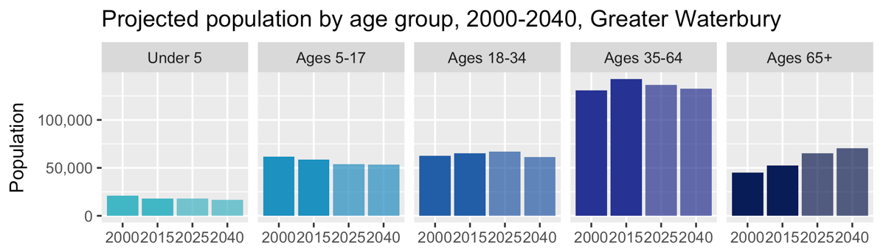

## ../../../_R/waterbury/demo_plots/age_race_mosaic_plot.pngRace and ethnicity

Waterbury is the urban core of the region, and is significantly more diverse than surrounding towns. People of color make up 25 percent of the region’s total population. However, in Waterbury, people of color make up 55 percent of the population and 36 percent of children under 18.

## Immigration

Eleven percent, or more than 35,000 residents, of Greater Waterbury’s population were born outside the United States. While, fifteen percent of the Waterbury’s residents are foreign-born. This can have ripple effect in the economy where immigrants play an important role in starting new businesses. This also has an effect on education where the school system must increase access to multi-lingual instructors for students.

* About 7 percent of the region’s residents have limited English proficiency; this rate is twice as high in Waterbury.

## Disparities

It is true that where you live can have an important impact on your wellbeing. In fact, socioeconomic factors and physical environment make up 50% of what effects a person’s health.[[1]](#footnote-1) Like other parts of Connecticut, residential areas in the Greater Waterbury region are segregated by race and income. While Waterbury is home to only one third of the region’s population, 76 percent of the region’s Black and Hispanic/Latino residents live in the city; similarly, 60 percent of the region’s low-income residents live in Waterbury. The historical and current roots of these differences, and their ongoing impacts have bearings on many aspects of life and health in our communities.

# Economic security – Page 4

## ../../../_R/waterbury/demo_plots/median_household_income_3geos.pngIncome

In addition to the physical environment, household income is an important health indicator which can reflect the ability to access medical care, healthy foods, and transportation. While twelve percent of the region’s population lives below the poverty line, including 30 percent of the region’s Black and Hispanic/Latino residents, nearly half of Waterbury residents are low-income.

Chronic illness disproportionately effects low-income communities. In Greater Waterbury, one quarter of the region’s population lives in low-income households (equivalent to just under $50,000 for a family of four). This number is higher for the most vulnerable populations in the region with 33 percent of children, and 26 percent of seniors, being low-income.

* Nearly half of Waterbury residents are low-income.

## Employment

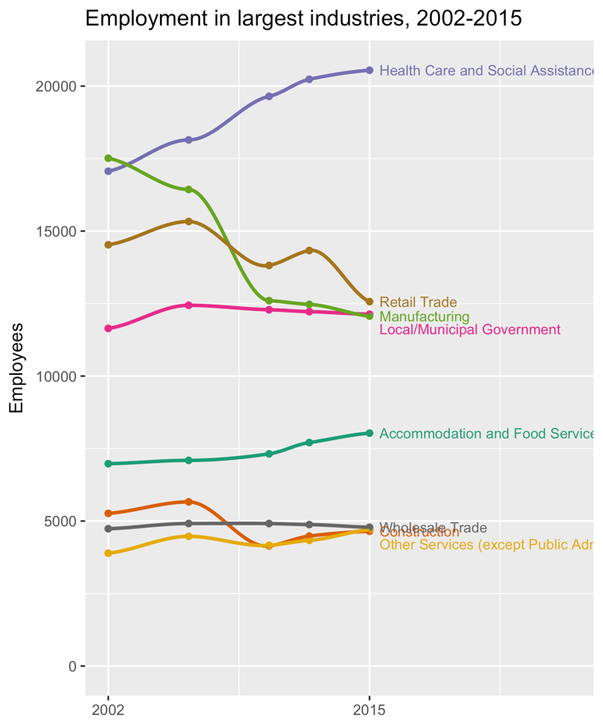Greater Waterbury is a robust economic region with a total of 112,063 jobs; about one third of these are located in Waterbury. Each day, 27,719 people commute into Waterbury for work, and 31,636 Waterbury residents leave the city for work. Access to health benefits, wellness programs, and important health prevention policies, such as paid sick leave, can help improve a person’s overall well-being.

Over the last decade, the shift from manufacturing and retail industries mirrored the rest of Connecticut and Northeast. Between 2002 and 2015, the region had a 2 percent loss in the number of jobs. The largest losses were in the manufacturing industry (31 percent loss). Shifts in employment industries is reflected in the 2016 regional unemployment rate of 5 percent.

* + The largest gains were in the health care and social assistance industry (20 percent gain)

# Physical Environment: Households – Page 5

Americans typically spend 90 percent of their time indoors, and two-thirds of that time is spent at home.[[2]](#footnote-2) In an exploration of the social determinants of health, Robert Wood Johnson Foundation highlights the interrelated nature of health to housing, noting that “the physical conditions within homes; conditions in the neighborhoods surrounding homes, and housing affordability” all are factors in a person’s health.[[3]](#footnote-3) Of the region’s 124,601 households:

* 70 percent own their home
* 27 percent are comprised of an adult living alone
* 20 percent are made up of married couples with children at home
* 9 percent are led by a single parent

The Putting on AIRS Program is an example of a program geared toward improving environmental conditions within the household. Putting on AIRS is a home visit program intended to help children and adults with poorly managed asthma. This is a free program funded by the Connecticut Department of Public Health and led regionally in Greater Waterbury by the Waterbury Health Department. The program provides three home visits by a Respiratory Therapist for one-on-one asthma education. Home visits are available days, evenings and weekends with certified medical translation available. In addition, the program provides a Healthy Homes assessment to identify environmental factors that can potentially trigger asthma attacks. This program is available to assist anyone with a diagnosis of asthma and whose asthma is considered poorly managed due to any of the following:

* One or more Emergency Department visits for asthma
* Hospitalizations or unscheduled medical visits within the past six months
* Has missed two or more school days in the past year due to asthma
* Visits the school nurse’s office more than two times per week due to asthma
* Has used three rescue inhaler canisters in six months
* Has activity limitations due to asthma

The Waterbury Health Department’s Lead and Healthy Homes Program is another example of improving environmental conditions within households. This program offers funding assistance to abate lead and other hazards for those who qualify.

The condition of homes in Greater Waterbury and the financial security of households varies greatly within the region. Seventeen percent of the region’s households are severely cost-burdened, meaning that they pay more than half their income toward housing costs. This rate is 25 percent within Waterbury, and 27 percent among all renters in the region.

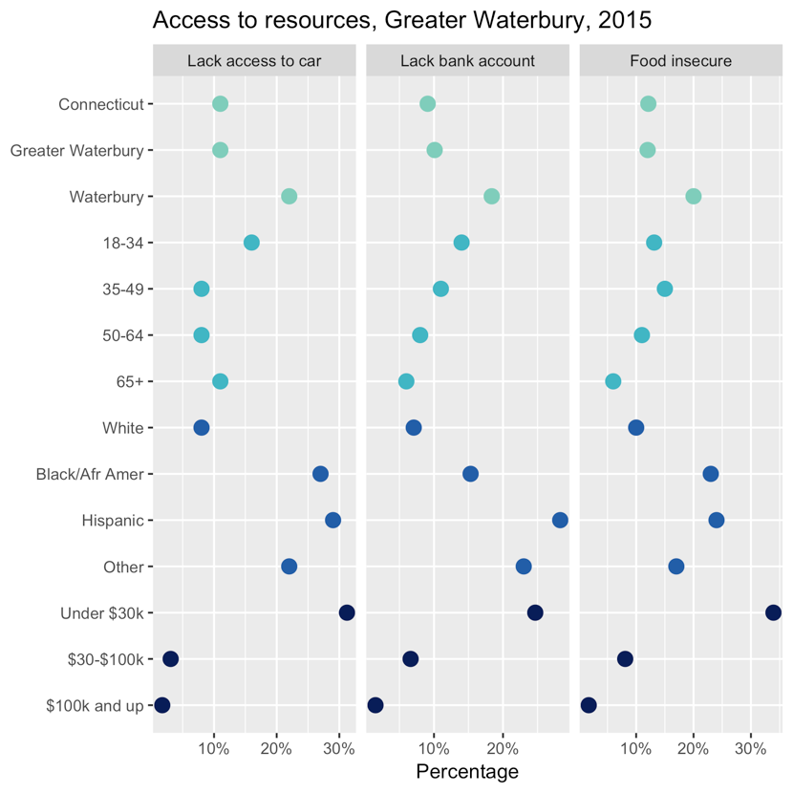

## Health Behaviors: Access to resources

As noted previously, income, housing, and employment are critical factors in community wellbeing. Equally as important is access to healthy foods, health education, and access to affordable transportation.

The following chart provides a demographic breakdown of regional access to resources comparing the state and Waterbury. As a region the majority of adults have access to a vehicle, with only 9 percent of households in Greater Waterbury and 19 percent in Waterbury without any vehicle.

Access to transportation plays an important role in people’s everyday lives, including how they are able to travel to work, to doctors’ appointments, to the grocery store, etc.

In 2015, 12 percent of adults in the region, and 20 percent in the city, reported being unable to afford food for themselves or their family at some point within the past year.

# Education – Page 6

## Greater Waterbury Health Partnership is not alone in working to improve community wellbeing. We collaborate closely with the Greater Waterbury Bridge to Success Community Partnership to ensure that children can succeed in school, work, and life. Educational achievement is linked to long-term health outcomes due to three basic factors: health knowledge and behavior, employment and income, and social emotional resilience.[[4]](#footnote-4) Access to early childhood experiences through child care and preschool is considered the foundation of future educational success.

## Early childhood experience

Currently there is a shortage of childcare slots in the region, with only enough slots available serve 20 percent of the region’s infants and toddlers, and 83 percent of the region’s children ages 3 and 4. These programs are often less accessible to low-income families due to their cost. Greater Waterbury’s preschool enrollment rate is 61 percent, yielding a total 4,759 preschool students ages 3 and 4.

Free childcare and education is available for infant, toddler, and preschool-aged children in the City of Waterbury through several national and state programs, including Head Start and School Readiness. However, even with free or subsidized programs, accessibility remains an issue in the city. The largest gap in availability of slots and compared to need exists in between the ages of 0-4, where only 47 percent of young children could be served with existing slots.[[5]](#footnote-5)

## K-12 public schools

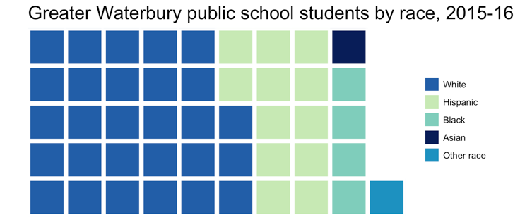The K-12 public school system in Greater Waterbury encompasses nine municipalities and five regional school districts. In total 49,348 students are enrolled in public schools across these districts. On par with the state’s graduation rate, the majority of students in the region (86 percent) graduate high school within four years. However, the demographic makeup of students varies greatly across the region, with the majority of student diversity in the City of Waterbury Public School System. The graduation rate for Waterbury public school students is 69 percent, which is significantly lower than the state or regional average.[[6]](#footnote-6)

* 44 percent of the region’s public school students, and 81 percent of students in Waterbury, are children of color

## Post-secondary attainment

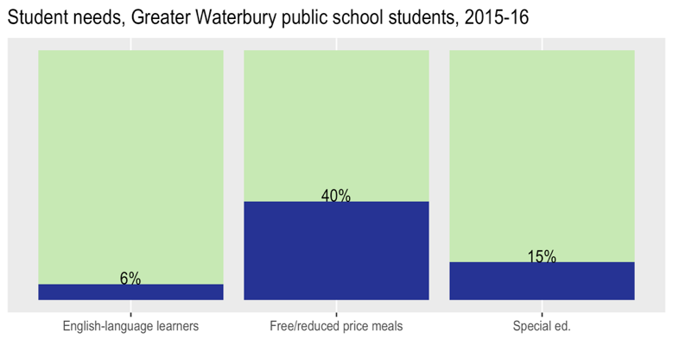As noted earlier, education is connected to health and wellbeing. Those with a college diploma will live an average of nine years longer than people without a high school diploma.[[7]](#footnote-7) Across the region 32 percent of adults ages 25 and up have a Bachelor’s degree or higher, while only 15 percent of adults in Waterbury have college degrees.

Waterbury has three institutions of higher education, Naugatuck Valley Community College, University of Connecticut Waterbury Branch, and Post University, which serve a regional and international cohort of students. More research is needed to determine how many of the graduates of these institutions stay in the region post-completion.

# Communities – Page 7

## Community well-being

Community well-being reflects how residents rate the environment they live in across a number of factors including: walkability, connection to neighbors, impression of safety, and access to food. These measurements provide an important perspective on how satisfied residents are in their communities. Overall, 80 percent of Greater Waterbury adults report being satisfied with the area where they live. On many measures of community well-being, residents’ feelings vary greatly by race, income, and location. On several community issues—such as trusting the police, feeling safe at night, feeling their local government is responsive to residents’ needs, or seeing their area as a good place to raise children—adults in the region fare much like residents statewide, but Waterbury residents lag behind.

Relative to surrounding suburbs, residents are more likely to report that Waterbury has safe sidewalks and many destinations within walking distance, though the city still lags behind larger Connecticut cities in these measures. Waterbury residents are much less likely than other parts of the state to report having safe places to ride bicycles. These data points can inform future planning and policy for the City with the goal of improving the environments where residents work, live, and play.

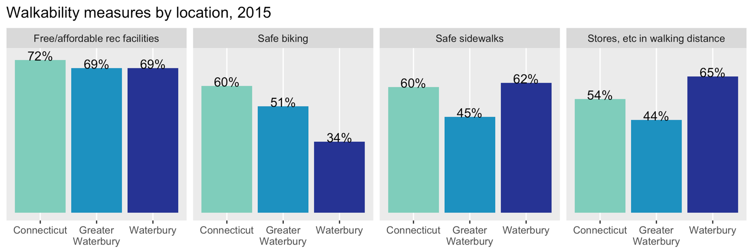

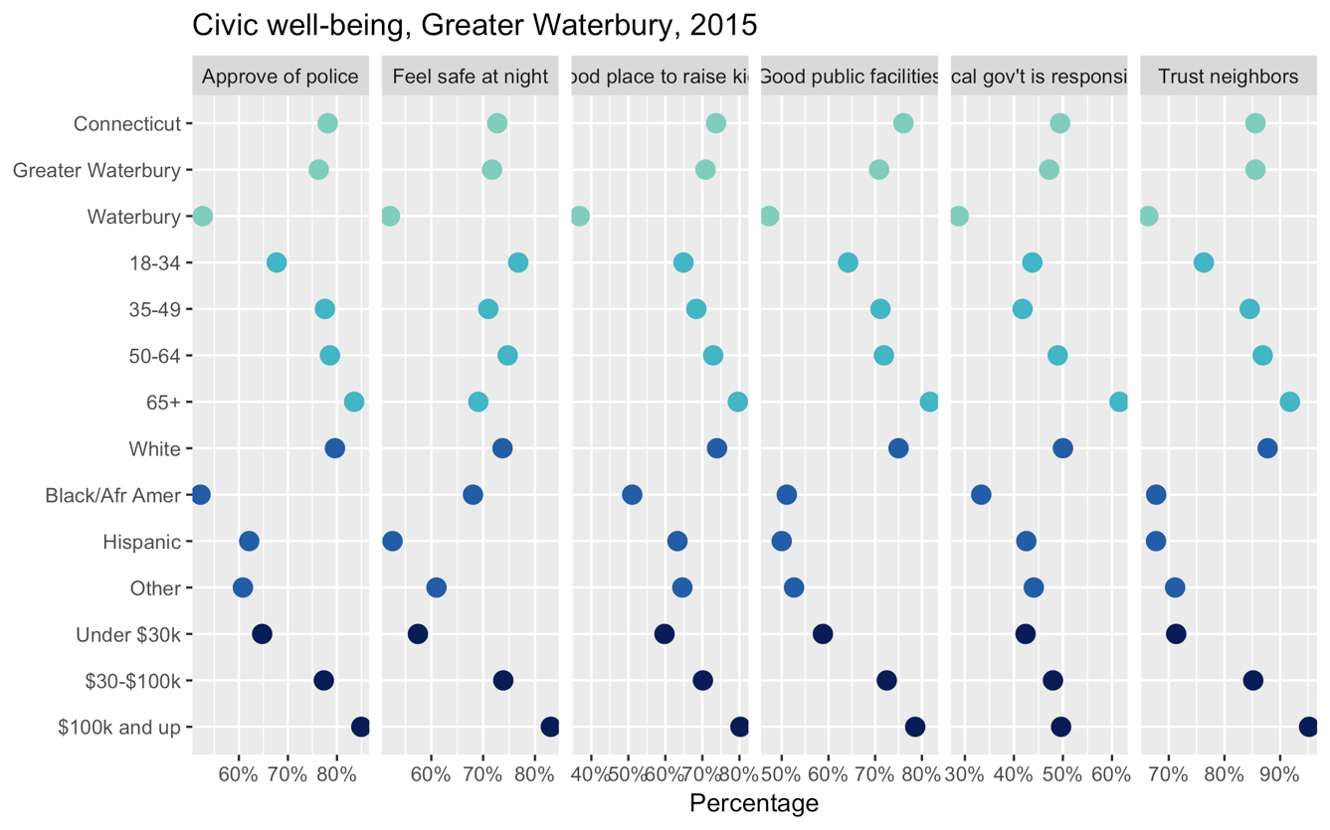

# Community Safety & Mortality– Page 8

## Causes of premature death

Community Safety and mortality statistics reflect socioeconomic factors that affect community well-being. These statistics reflect accidental deaths related to community safety issues, premature death related to heath, injuries, and in some cases violent crimes.

One way to quantify premature death is to measure it by the years of potential life lost (YPLL) before age 75 per 100,000 residents, where each death represents a loss of human potential.

In the City of Waterbury, the greatest loss of years of life arises from fetal and infant mortality, injuries (including accidental overdoses and motor vehicle crashes), cancer, and heart disease. People living in the City of Waterbury are much more affected by infant mortality, overdoes and other injuries, and heart disease compared to the state. Suburban areas in the region are similar to the rest of Connecticut in the causes of premature death and YPLL.

## Substance abuse

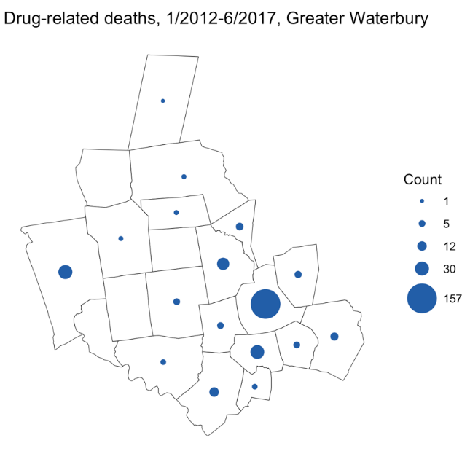As is the case both statewide and nationwide, the number of deaths from substance use, particularly opioids, has rapidly increased over the past several years in Greater Waterbury. From January 2012 through June 2017, 350 residents of Greater Waterbury towns died of drug overdoses; just over half of these deaths were of Waterbury residents.

The Waterbury Health Department is part of Connecticut’s Opioid REsponse Initiative (CORE), which was designed with expertise from the Yale School of Medicine. CORE is funded by the Connecticut Department of Public Health (CTDPH) and implements the strategies developed locally by the Mayor’s Opioid Task Force. The Waterbury CORE program provides Safe Use- Safe Storage- Safe Disposal strategies from a public safety perspective and relies on close collaboration among Waterbury Health, Waterbury Fire and Waterbury Police Departments. Additionally, Waterbury CORE is designed for easy adoption and customization of CORE strategies by other public safety entities throughout the broader region to extend the reach of the strategies.

Health Outcomes – Page 9

Connecticut is overall a quite healthy state, and Greater Waterbury residents fare about as well as the state on many measures of health. However, there are large differences in health outcomes by income, race, and location within the region. 83 percent of adults in the region report their health as good or excellent, but Black and Hispanic/Latino residents are less likely to rate their health as highly. Only 64 percent of adults with incomes below $30,000 rate their health as good or excellent, while 97 percent of adults with incomes of at least $100,000 report the same.

Adults in low-income neighborhoods are several times more likely to be hospitalized for severe conditions such as heart disease and diabetes at an early age. Middle-aged adults in the state’s four largest cities—including Waterbury—were more likely to be admitted to the hospital for heart disease than were seniors ages 65–74 in wealthy communities. Local access to evidence-based classes are now an important tool for people managing chronic disease.

Pomperaug Health District offers Live Well Chronic Disease Self-Management and Live Well with Diabetes classes on a periodic basis. These programs are part of the Connecticut Healthy Living Collective.

Live Well and Live Well with Diabetes are evidence-based workshops that aim to teach participants how to better manage their health issues and improve their overall health. Live Well focuses on helping patients manage their chronic health conditions ranging from arthritis to heart disease and living a healthy lifestyle. Live Well with Diabetes focuses on helping the patients manage their diabetes by teaching nutrition and healthy lifestyle. These workshops are free to participants and are held once per week for six weeks at various community locations. Live Well and Live Well with Diabetes workshops in English and Spanish will soon be offered at more locations in Waterbury.

* 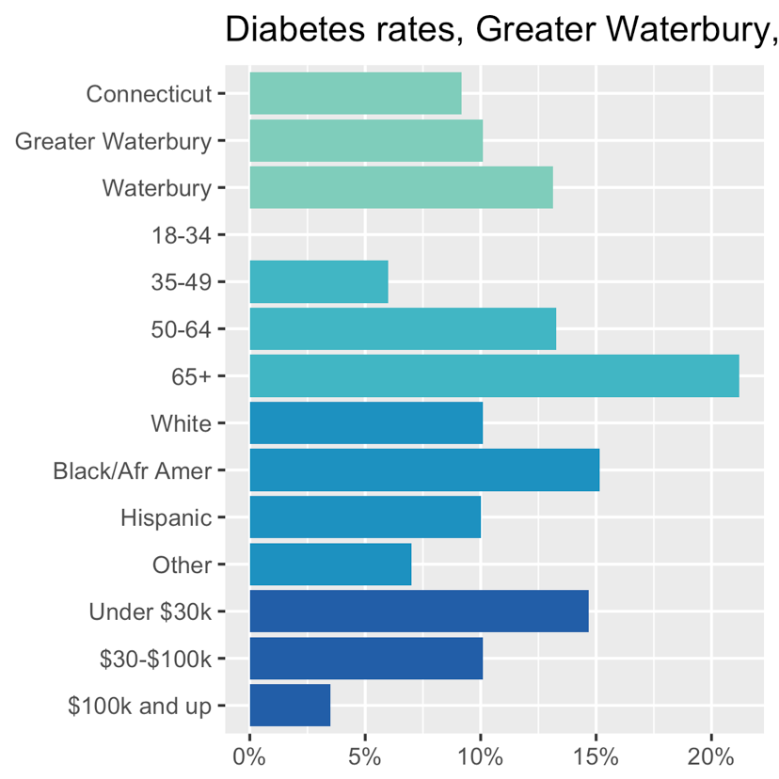Thirteen percent of adults have asthma, with higher rates in the city.

# Health risk factors – Pages 10-11

As is the case with health outcomes, many health risks and barriers to preventive care are distributed unevenly throughout the state and region. The following is a snapshot of how well the region’s residents access medical care and dental care, as well as how many resident currently smoke.

In 2015, low-income residents (incomes under $30,000) were 3 times more likely to report having delayed or not received medical care they needed within the past year compared to residents with incomes of $100,000 or more.

Access to dental care is an important indicator of overall health. Trends in access to dental care mirror other medical care, in that the low-income residents are less likely to receive care. About 8 in 10 adults in the region received care from a dentist within the past year, but only about 6 in 10 residents with incomes under $30,000 did. Lack of access for low-income communities reflects a national trend in dental care shortage due to lack of providers.[[8]](#footnote-8) Not having access to regular dentist visits can have a negative impact on health and lead to more severe conditions, including pain, infection and tooth loss.

While other health risk factors in the region show similar trends to the state, regionally Greater Waterbury has a 17 percent adult smoking rate; Waterbury’s rate is 25 percent. Both of these rates are higher than the statewide average of 15 percent. Research shows that on average, smokers die 10 years earlier than nonsmokers and has a real economic impact on communities.[[9]](#footnote-9) Recognizing the negative impact on the City of Waterbury, the Greater Waterbury Health Partnership has explored the expansion of tobacco and smoke free areas in public parks and community spaces as one way to curb negative effects on the community.

The Greater Waterbury Region relates in many ways to the rest of the State of Connecticut. In order to improve the health of Greater Waterbury residents, efforts are being made to develop and implement programs geared toward health education and health access within the region. The endeavor made to support and implement health programming will be done in an effort to decrease health risk factors and increase health education of Greater Waterbury residents which will lead to a healthier community for all.

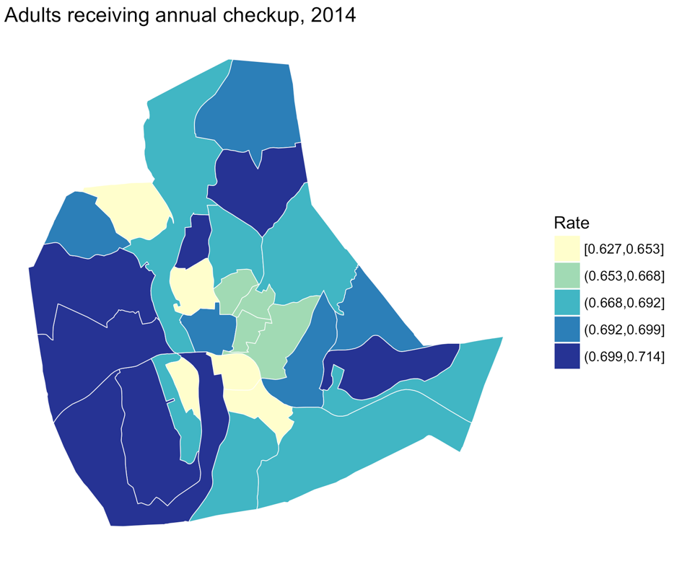

# Health risk factors (continued)

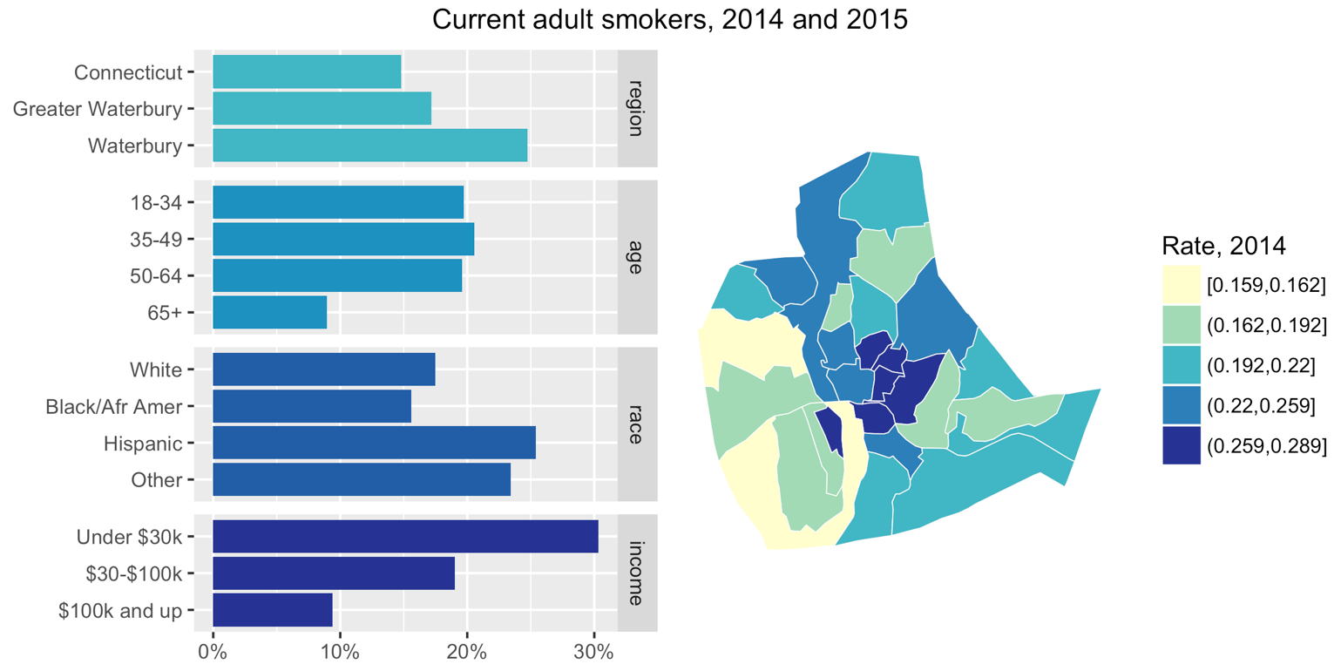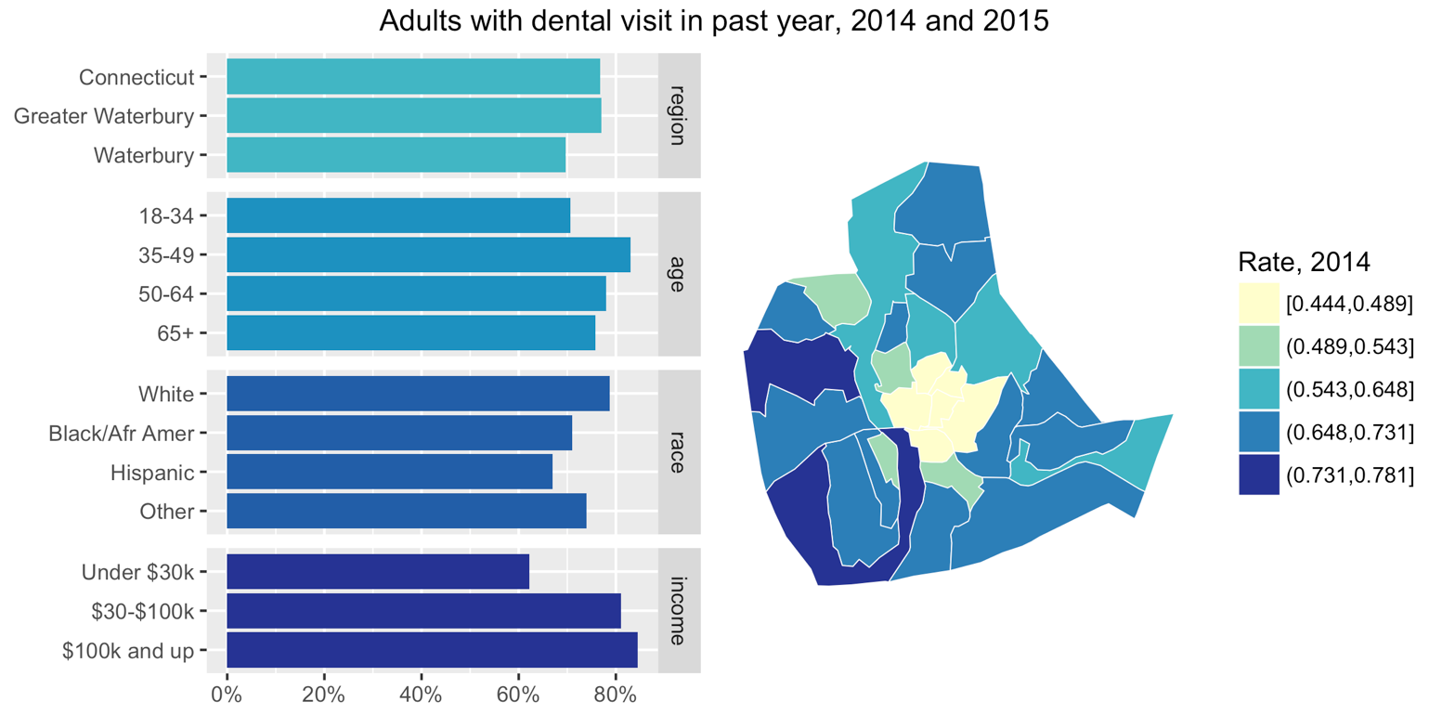

# Back cover – Page 12

Sources:

* 2-1-1 Child Care Connecticut, Annual Child Care Capacity, Availability, and Enrollment Survey 2016
* 2015 DataHaven Community Wellbeing Survey
* Bureau of Labor Statistics, Quarterly Census of Employment and Wages
* Centers for Disease Control and Prevention, Behavioral Risk Factor Surveillance System
* Connecticut Department of Public Health, Years of Potential Life Lost
* Connecticut Office of the Chief Medical Examiner, Accidental Drug Related Deaths 2012-June 2017
* Connecticut State Data Center, 2015 to 2040 Population Projections for Connecticut
* Connecticut State Department of Education, EdSight
* US Census Bureau, 2000 and 2010 Decennial Census
* US Census Bureau, American Community Survey 2015 5-year estimates
* US Census Bureau, Longitudinal Employer-Household Dynamics Origin-Destination Employment Statistics

1. http://www.countyhealthrankings.org/our-approach/health-factors [↑](#footnote-ref-1)
2. https://www.rwjf.org/content/dam/farm/reports/issue\_briefs/2011/rwjf70451 [↑](#footnote-ref-2)
3. Ibid [↑](#footnote-ref-3)
4. <https://www.rwjf.org/content/dam/farm/reports/issue_briefs/2011/rwjf70447> [↑](#footnote-ref-4)
5. Childcare Enrollment and Accessibility in Waterbury, 2016, prepared by DataHaven [↑](#footnote-ref-5)
6. Connecticut State Department of Education, *District Profile and Performance Report for School Year 2015-2016,* Waterbury School District, CERC Town Profile (http://profiles.ctdata.org/profiles/) [↑](#footnote-ref-6)
7. <https://www.rwjf.org/en/library/research/2014/01/education--it-matters-more-to-health-than-ever-before.html> [↑](#footnote-ref-7)
8. <http://www.countyhealthrankings.org/measure/dentists> [↑](#footnote-ref-8)
9. <http://www.countyhealthrankings.org/our-approach/health-factors/tobacco-use> [↑](#footnote-ref-9)